### Usability Test

|  |  |  |  |  |  |
| --- | --- | --- | --- | --- | --- |
| No. | Test Title | Pre-Condition | Test Steps | Expected Results | Actual Results |
| 01. | Navigation bar | Accessible form home page and any other pages | Click on any option to view the detail of the page from the navigation bar. | The test result was as expected. | As expected. |

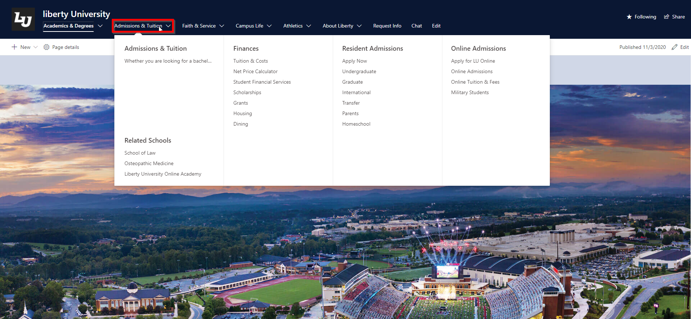

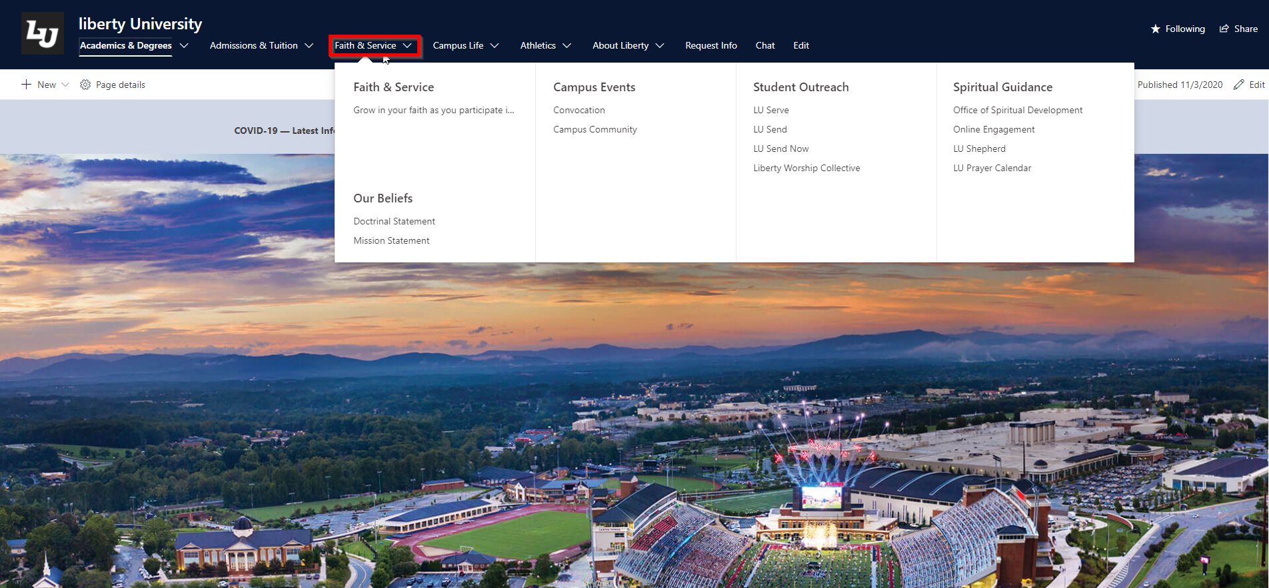

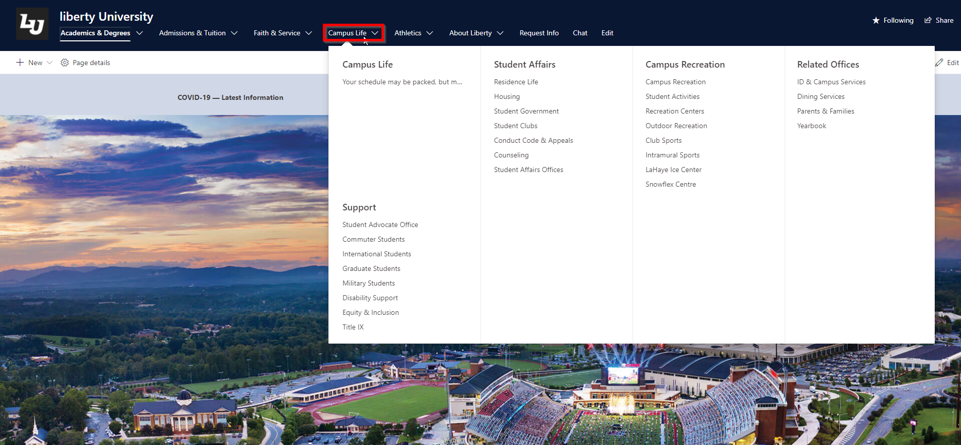

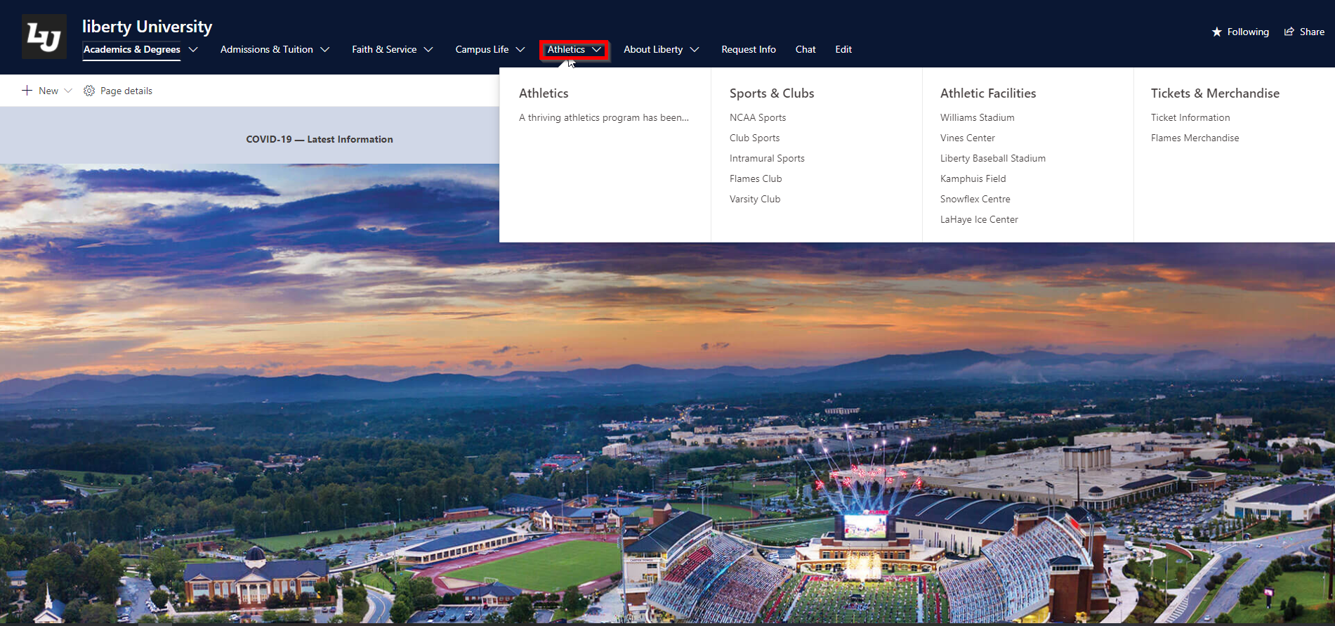

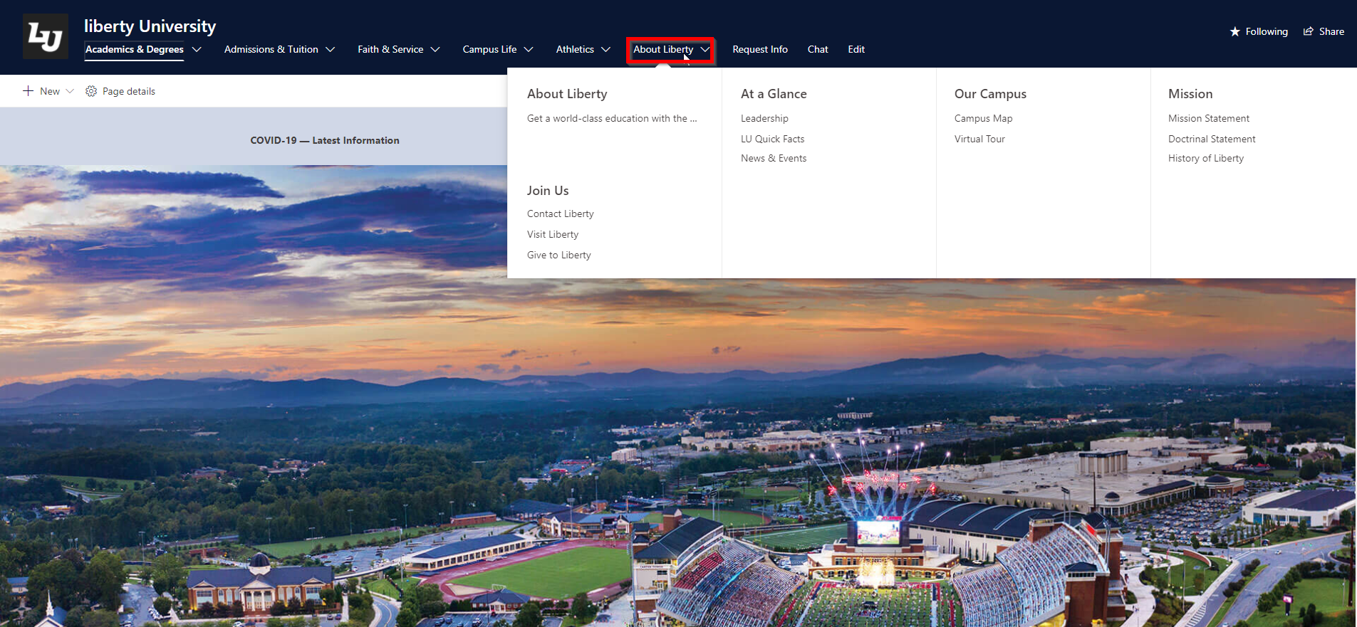

|  |  |  |  |  |  |
| --- | --- | --- | --- | --- | --- |
| No. | Test Title | Pre-Condition | Test Steps | Expected Results | Actual Results |
| 02. | Easy access to the about page | Accessible form home page and any other pages | Select the About Page to view the about page detail. | The test result was as expected. | As expected. |

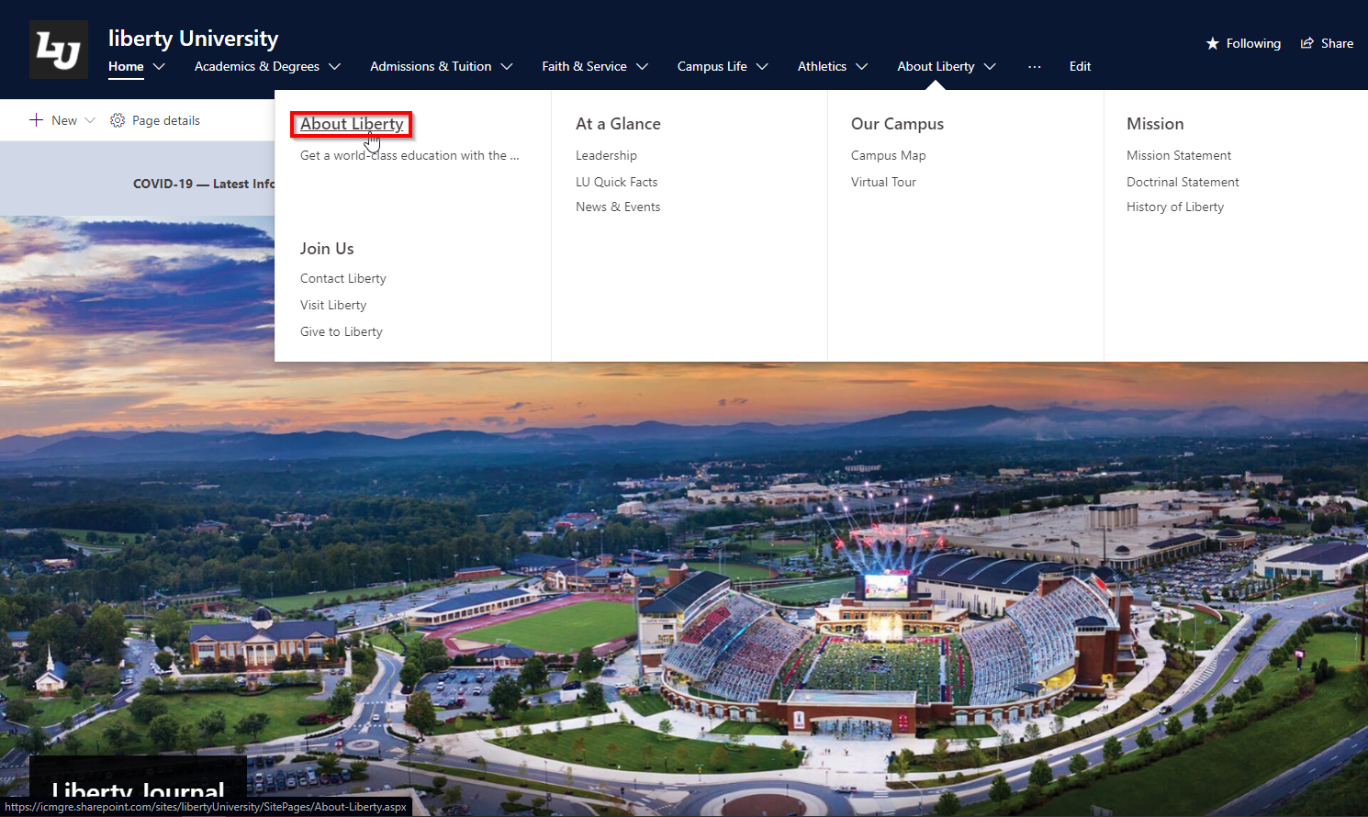

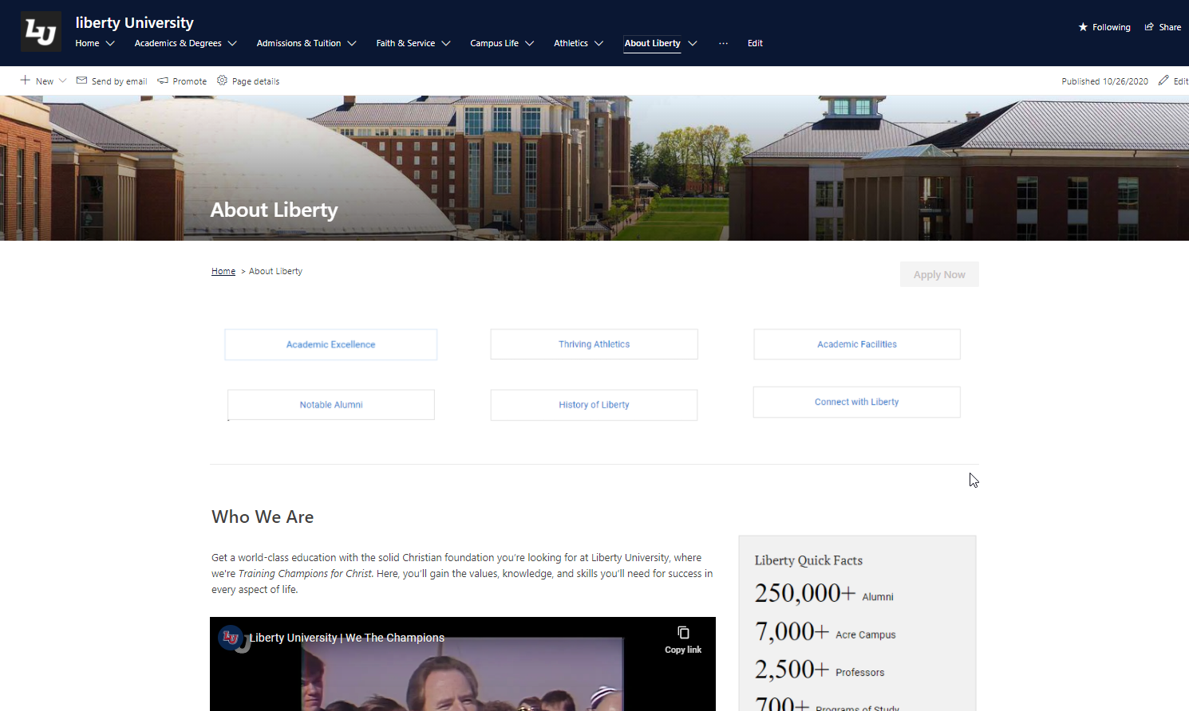

|  |  |  |  |  |  |
| --- | --- | --- | --- | --- | --- |
| No. | Test Title | Pre-Condition | Test Steps | Expected Results | Actual Results |
| 03. | Detailed and working footer | Accessible to the footer from all the available pages. | Select the workable option and buttons from the footer. | The test result was as expected. | As expected. |

